Personal Investigation Introduction
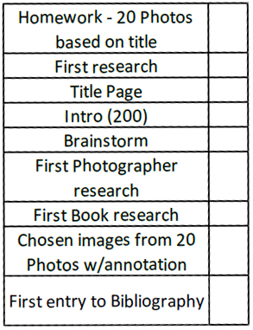
You should already have the following in your project. You may complete the following in a book of your choice. You may also use any suitable digital publisher such as PowerPoint or InDesign. Remember that if you don’t have PowerPoint at home, you can use the whole Office Suite FREE OF CHARGE using a OneDrive account. Open Office is also a compatible piece of software that is a free download
--------------------------------------------------------------------------------
During the holidays, you are to complete at least 1 gallery, exhibition or related visit. This could be a visit to a gallery with a permanent collection of work; an exhibition dedicated to theory/genre/technique/movement/photographer; or it could be a visit to a studio or practitioner that you have researched. Collect as many photos and literature as possible. Remember to keep all emails you may send and document all websites, books and magazines for your bibliography.

As you conduct your research during the summer, you are also to produce a 2 minute video showing your investigation and project theme. You should be including photos and short clips within it.
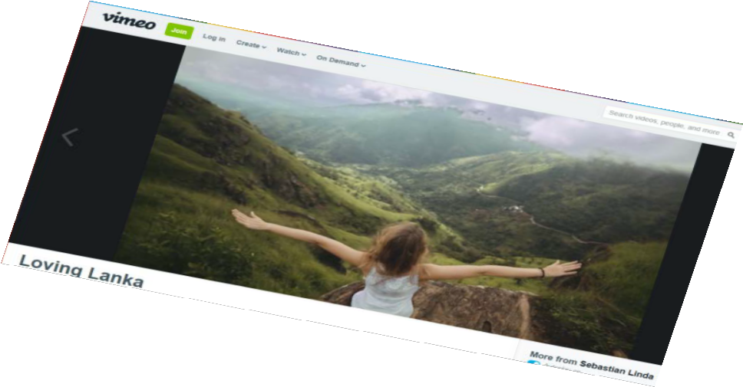
Consider your use of music/speech and what affects you could add. Speeding up a dull 30 second video to 10 seconds can create something more exciting. Clips can be recorded using your phones or compact cameras and the finished video can be
completed using iMovie, Windows Movie Maker or a piece of software/app of your choice.

A fantastic example is the video ‘Loving Lanka’ on Vimeo
(https://vimeo.com/132038125) .
Obviously we are not expecting you to travel
the world for this video, but think about how you can
produce and exciting and thought provoking video using photos and clips
during your summer. They can be taken anywhere and show anything, but they must be
your own and they must relate to your theme. Remember to bring in all your photos and videos on a
USB stick as they will also be used in your project.

rjs@rws.uk.net
@RWSPhotoDept

