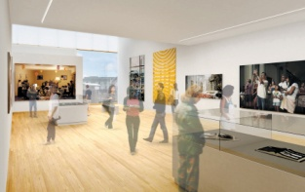
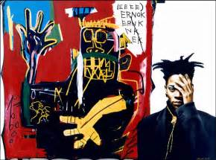
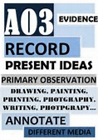
Year 11 - HOMEWORK– due 6th Nov 2017
UNIT 1 – C/W - DEVELOPING IDEAS - JOURNEYS
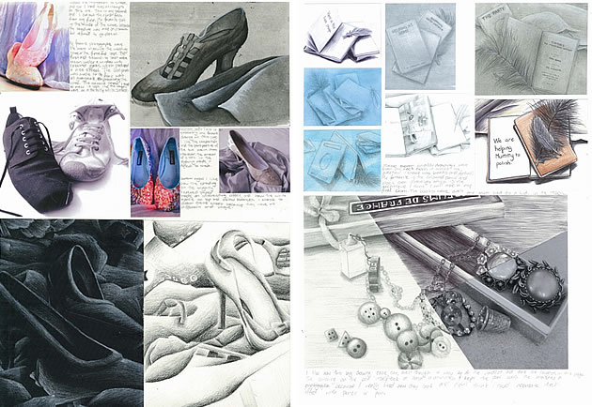
During Oct Half Term, you are tasked with producing an A03 Ideas page packed with observational drawings or photographs.
Start by creating sketchbook pages which include at least 3 different compositions (linked to Journeys theme) which have been developed and personalised by you. For example, draw an object or souvenir which reminds you of a place or visit.
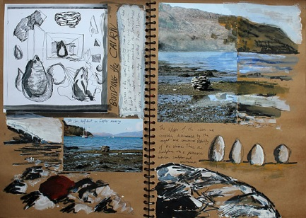
Or create your own version of an artist’s work but include your own style or ideas in the piece. Or take photographs linked to your theme which show a range of viewpoints or interesting angles. Drawings and sketchbook pages can be in any medium, should be visually interesting and include your annotations to explain thoughts, ideas and processes.
To extend this task, visit an Art exhibition, gallery or museum to extend your starting points. Remember the more work your produce in art, the more marks you can potentially pick up for experimentation, planning and observational studies.
Art shows happening in London during Oct/Nov half term:

Rachel Whiteread sculpture - Tate Modern, London:
http://www.tate.org.uk/whats-on/tate-britain/exhibition/rachel-whiteread

Taylor Wessing Photographic Portrait Prize - National Portrait Gallery, London: http://www.npg.org.uk/whatson/twppp-2017/exhibition/

Jean-Michel Basquiat exhibition – Barbican Art Gallery, London:
https://www.barbican.org.uk/whats-on/2017/event/basquiat-boom-for-real?ID=20335

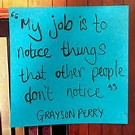
Bethlem Museum of the Mind, Beckenham - Free exhibits which celebrate the achievements of artist’s effected by mental health: http://museumofthemind.org.uk/

Get ahead over the half term as you have just 7 weeks to finish coursework (unit 1, worth 60% of your GCSE marks) when you return.

